***Email alert for Jenkins job with deployment in tomcat server***

* Here first we need to create instance for Jenkins

INSTANCE

🡪 AMI: UBUNTU

🡪 type: t2.large;

🡪 keypair : charan (any-thing optional)

🡪Security group: add port number 8080 and give IPv4anywhere (0.0.0.0/0)

🡪Click on lunch instance   
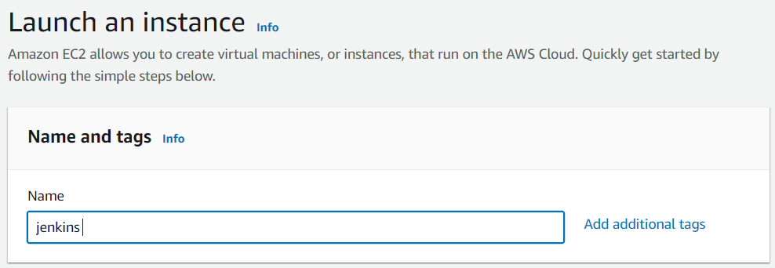

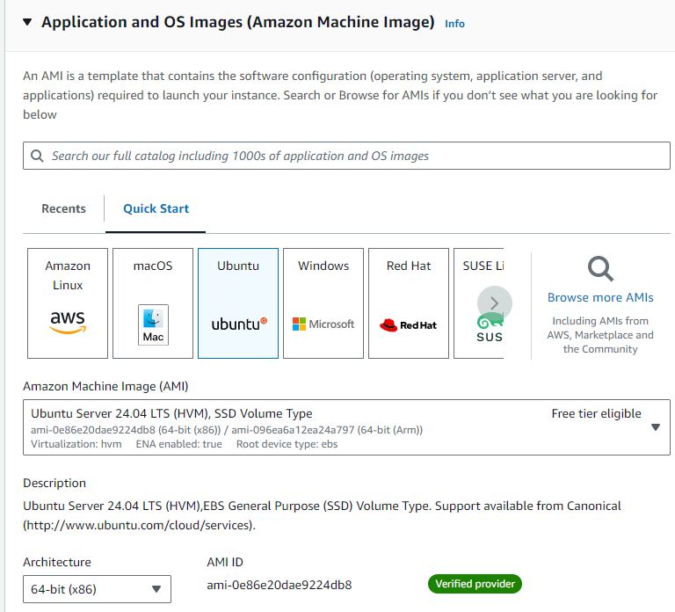

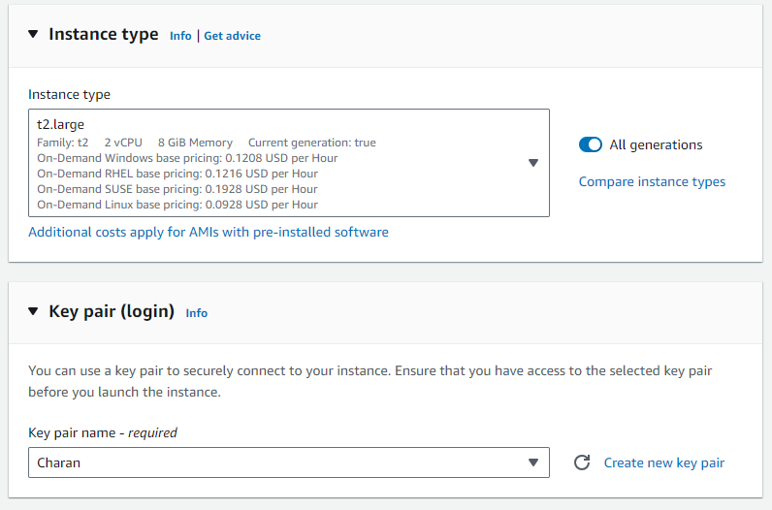

* Add the security group in the network settings with port number 8080 and source (0.0.0.0/0)

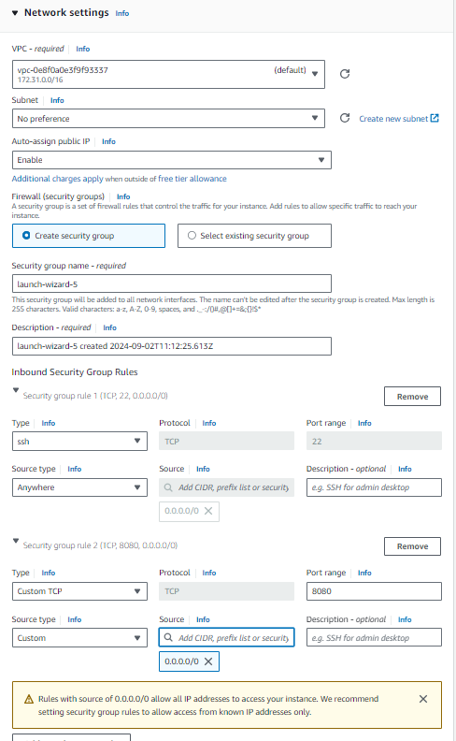

* Click on lunch instance

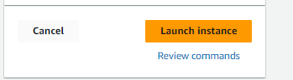

* Connect to Jenkins ec2 in the browser form the following installation

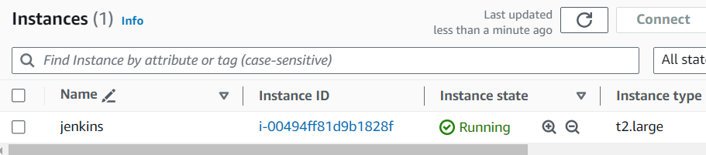

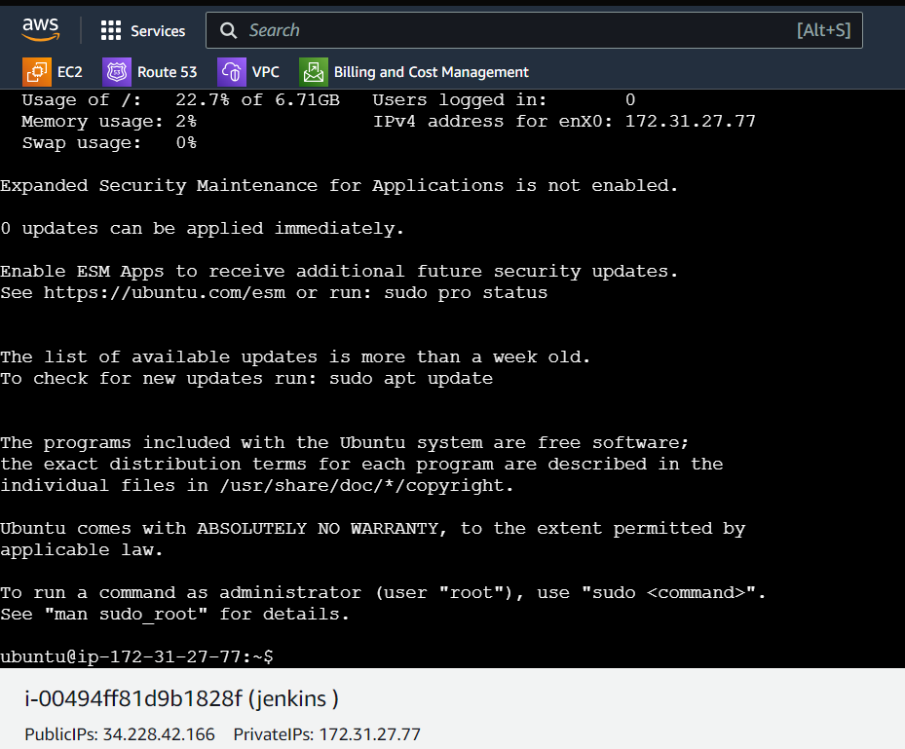

* Sudo – i
* apt update -y && apt install default-jdk -y && apt install maven -y

1. The above command updates the machine and next it installs default -jdk (java) also install’s maven.

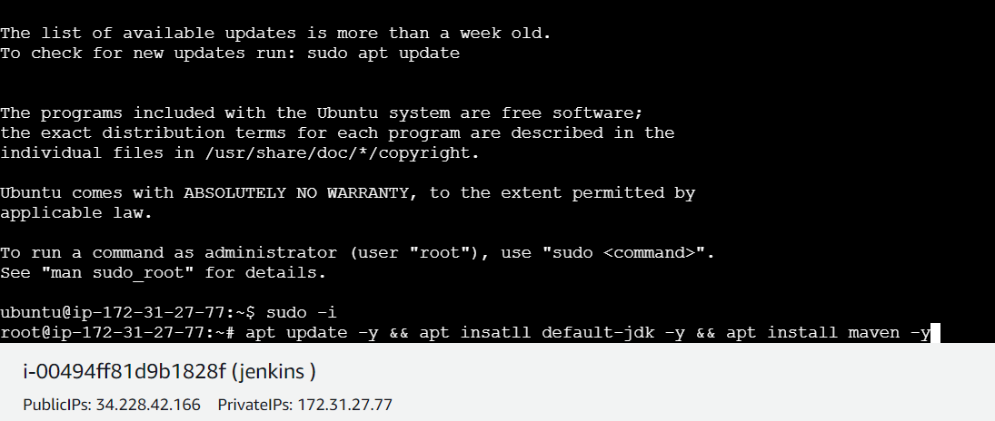

* Now click on enter to install the following java & maven & update
* After that we need to install Jenkins which is available in the browser

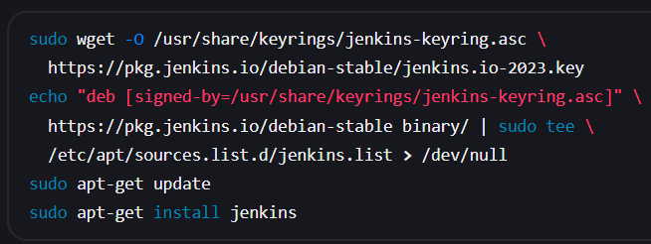

* Copy and past in the server to install Jenkins & click on enter to install Jenkins

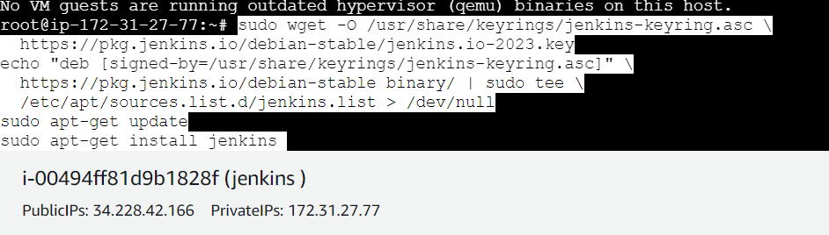

* Now copy the public ip of the server past it in the browser with the port number 8080 in the last (34.228.42.166:8080)

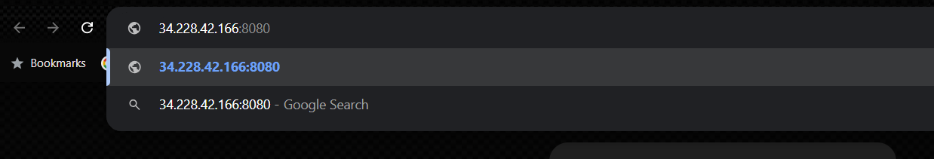

* After you enter the public ip of Jenkins it ask’s to unlock there it shows an path for the password to unlock Jenkins copy the path to see the password in the server

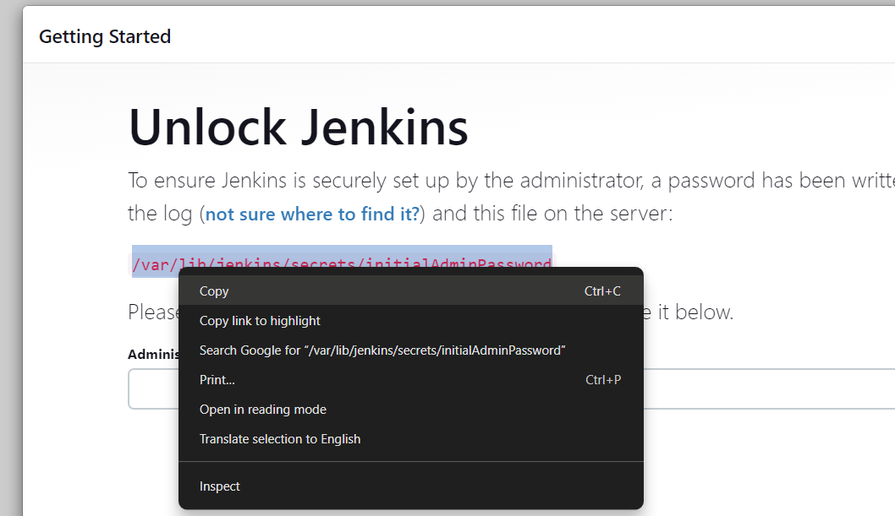

* Now past the path with cat to see the password and past the password in the Jenkins browser to unlock the Jenkins

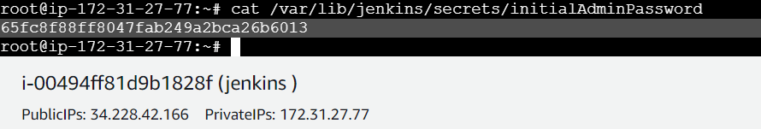

* Click on continue to unlock jenkins

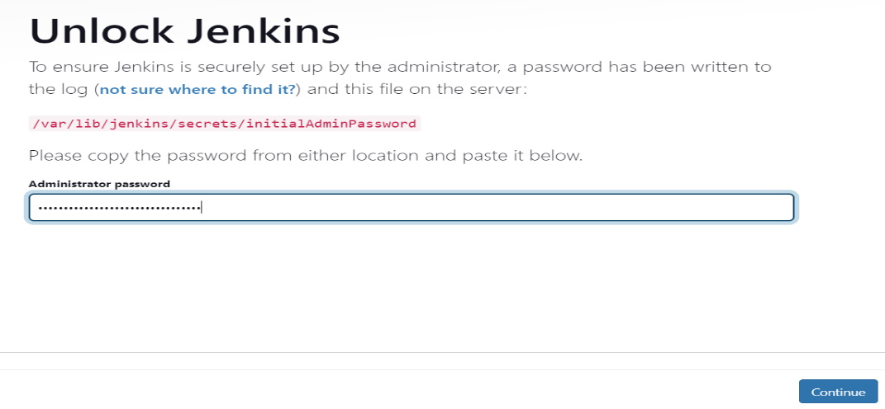

* Click on install suggested plugins

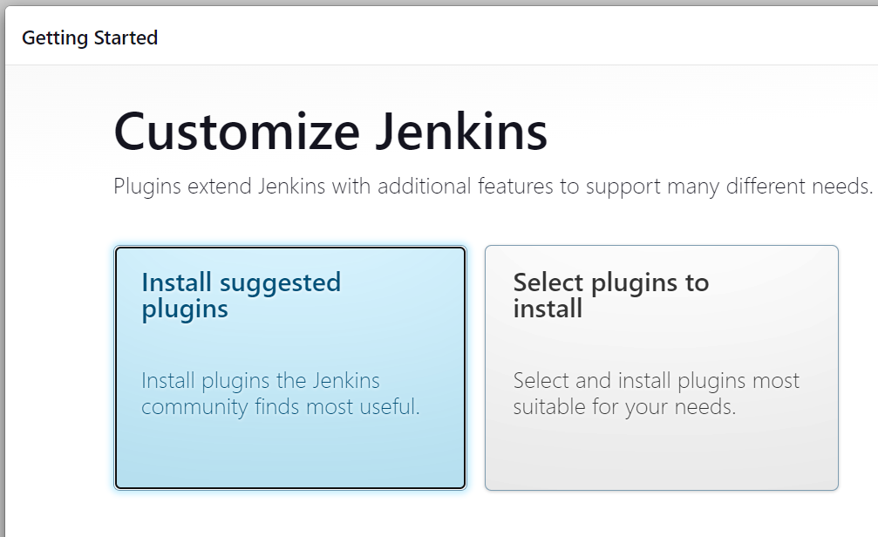

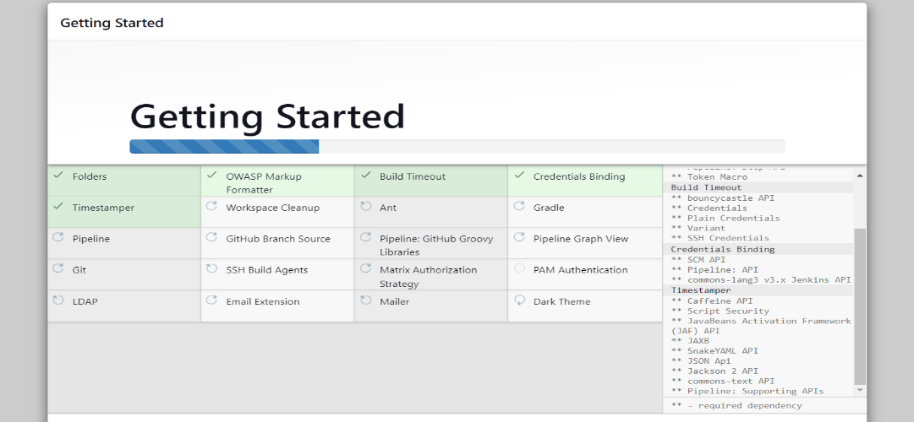

* Next here enter username & password &full name & email address next click on save and continue

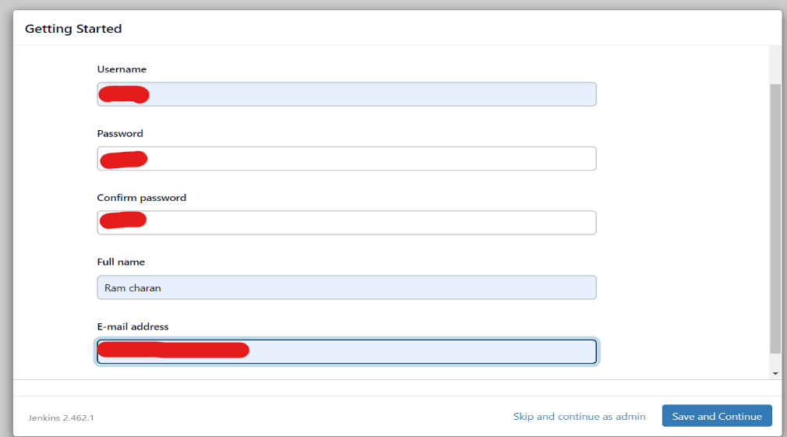

* Next instance configuration with URL

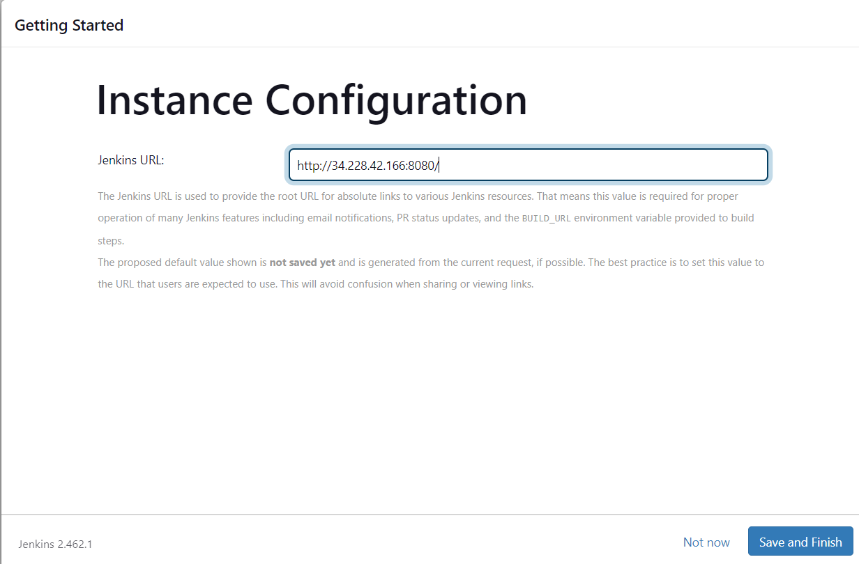

* Now click on start using Jenkins

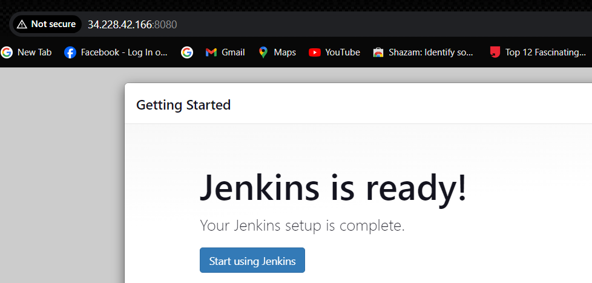

* You can see the Jenkins dashboard link this

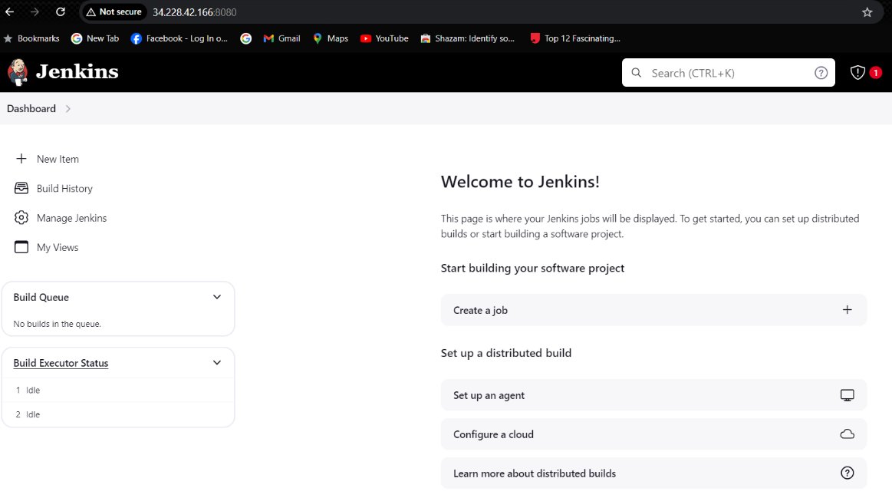

* we need to install two plugins in the manager Jenkins 🡪 plugins
* Email extension template
* Deploy to container

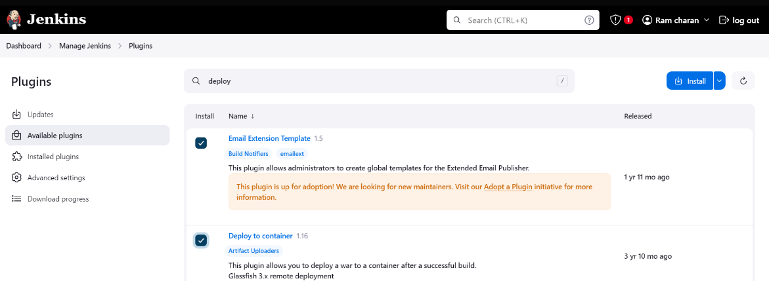

* Click on install the plugin the restart the Jenkins server

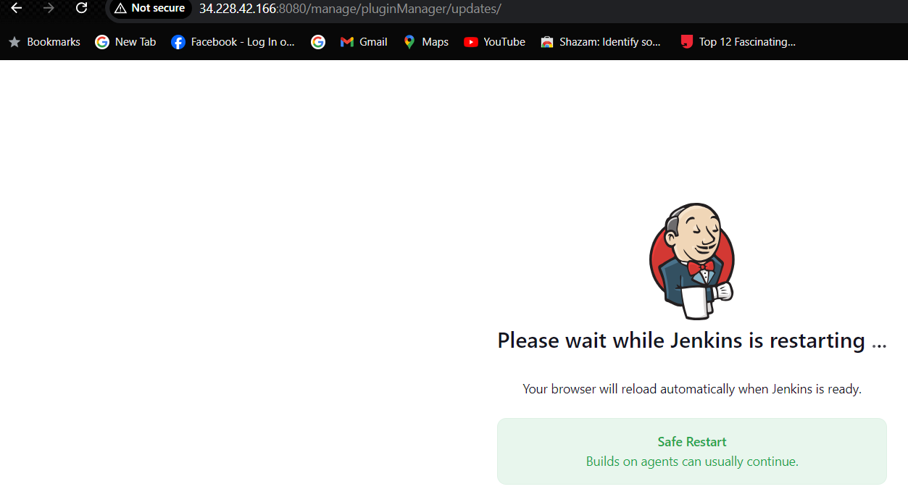

* After your restarting the Jenkins it will ask’s to login Jenkins

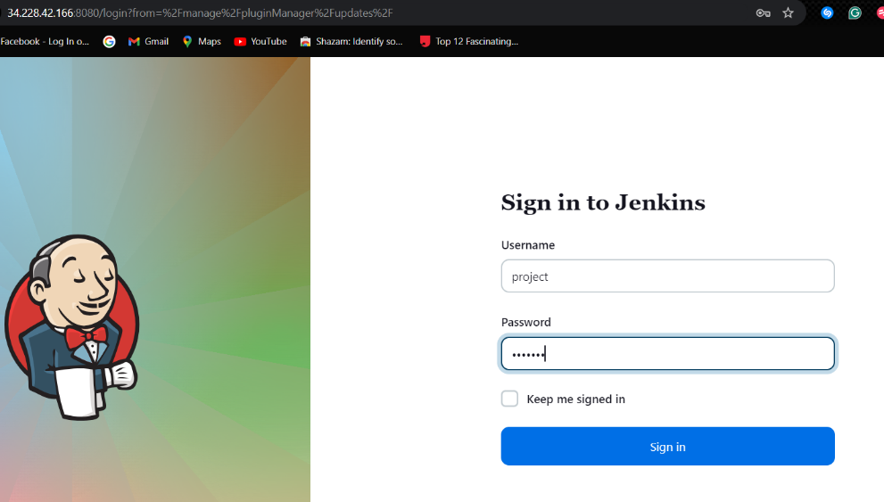

* Now we need a tomcat server form the deployment of java application in the server. So keep Jenkins aside for some time after tomcat we can return to Jenkins
* let’s go and launch an instance for the tomcat

🡪AMI: UBUNTU

🡪type: t2.micro

🡪keypair: charan (any-thing optional)

🡪 Security group: add port number 8080 and give IPv4anywhere (0.0.0.0/0)

🡪launch instance

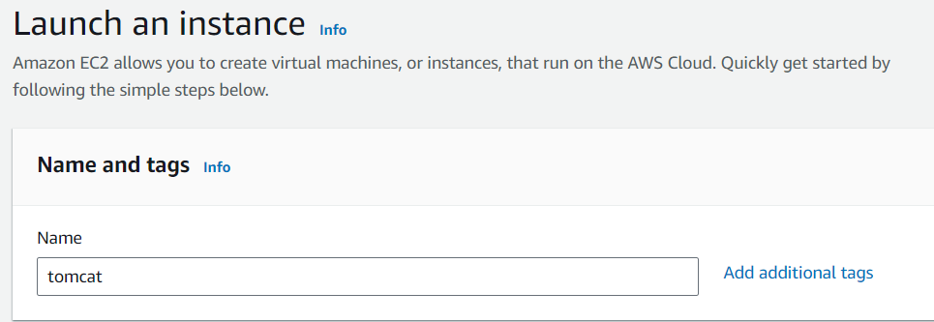

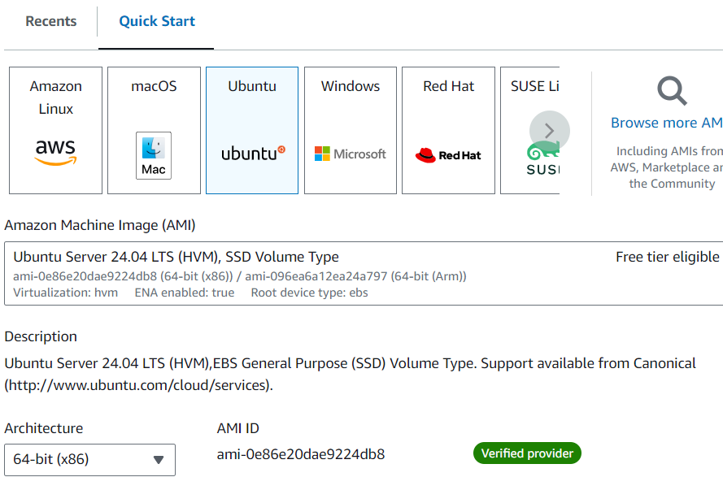

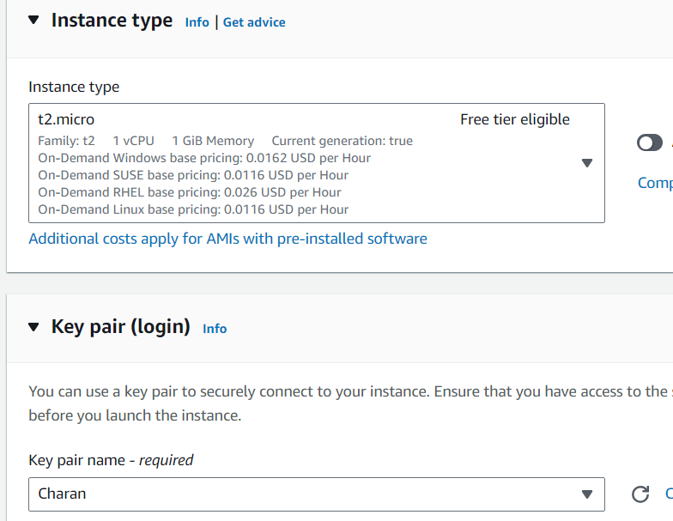

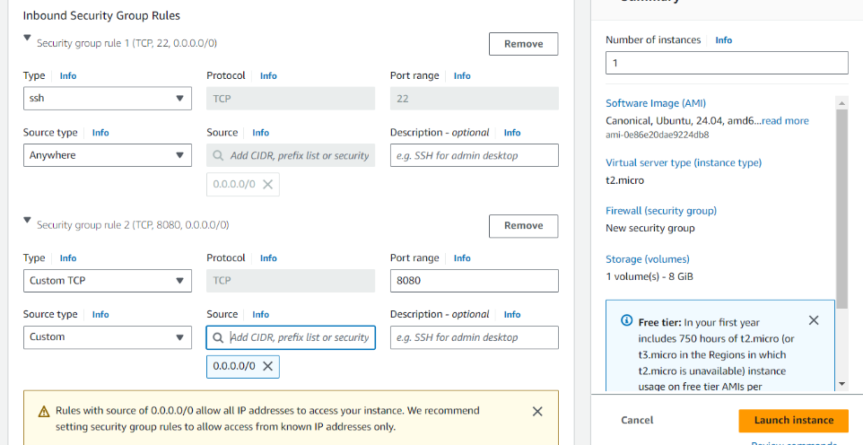

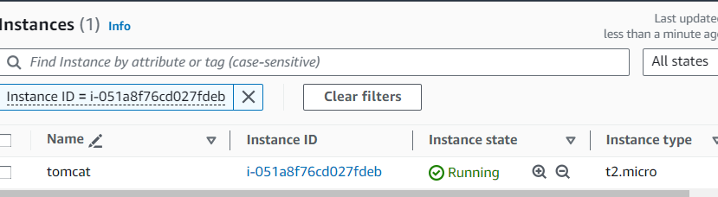

* connect to the tomcat server in the browse

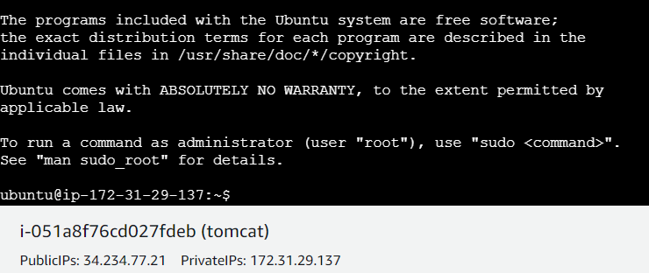

* sudo -I && apt update -y && wget <https://dlcdn.apache.org/tomcat/tomcat-9/v9.0.93/bin/apache-tomcat-9.0.93.tar.gz> && apt install default-jdk -y
* ls
* tar -xvzf apache-tomcat-9.0.93.tar.gz

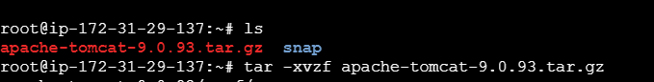

* ls
* mv apache-tomcat-9.0.93 tomcat
* cd tomcat

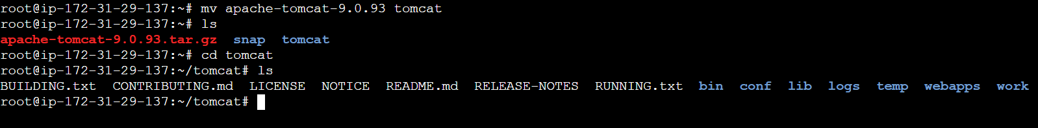

* cd wedapps
* cd host-manager
* cd META-INF
* vi context.xml

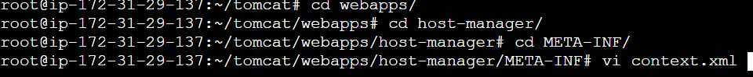

* vi.context.xml by default it will be as shown below  
  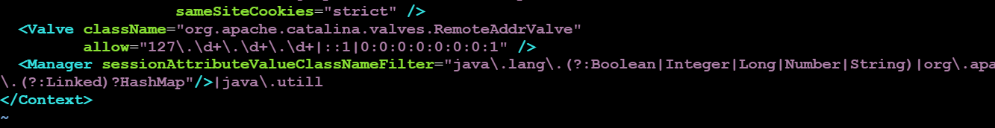
* add the <! -- under the samesitecookes and add --> near the allows

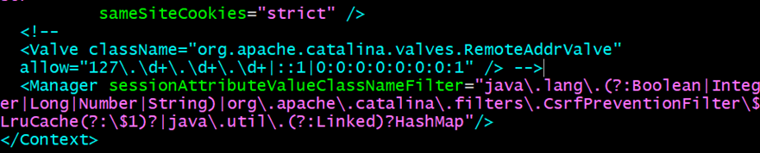

* **Exit the vi context.xml**
* **Cd ..**
* **Cd ..**
* **Cd manager**
* **Cd META-INF**
* **Vi context.xml**

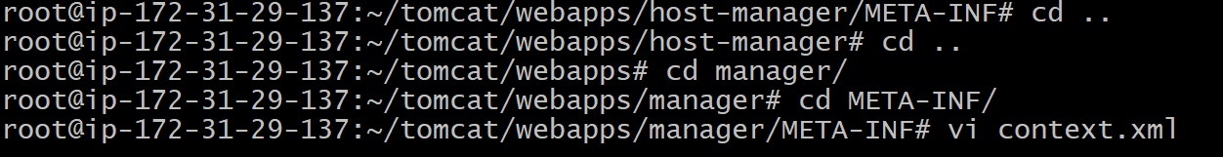

* **Vi context.xml by default it will be as shown below**

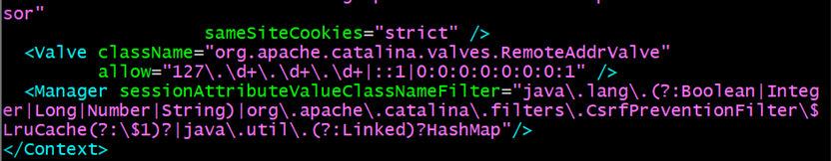

* **add the <! -- under the samesitecookes and add --> near the allows**



* **Exit the vi context.xml**
* **Cd ..**
* **Cd ..**
* **Cd ..**

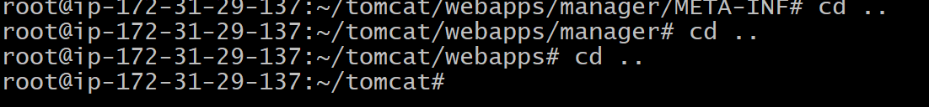

* **Cd conf**
* **Vi tomcat-user.xml**



* **in tomcat-user.xml by default it will be as show below**

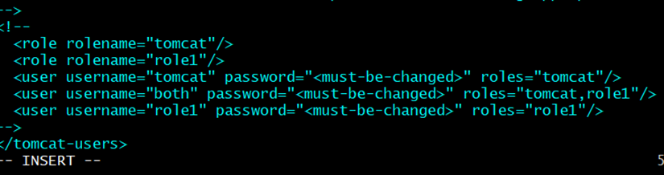

* **Add the manager-gui, manager-script, manager-jmx, manager-status. After adding the following**

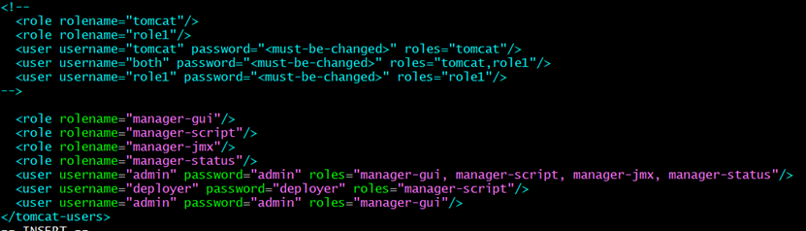

* **Exit the vi tomcat-user.xml**
* **Cd ..**
* **Cd bin**
* **Ls**

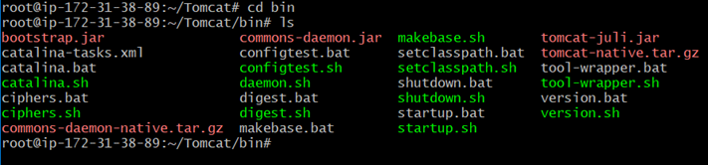

* **./startup.sh**

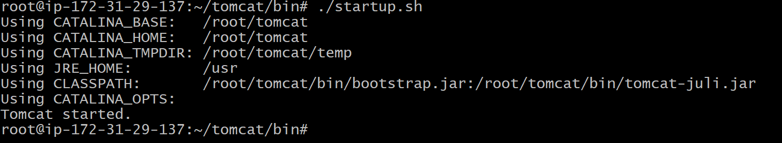

* **Next copy the public ip of tomcat and past in the browser with port number 8080 in the last**

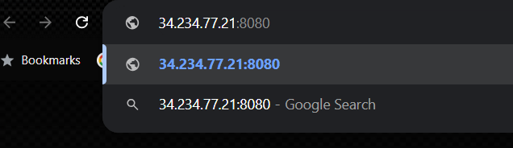

* **Press entre then tomcat server appears**

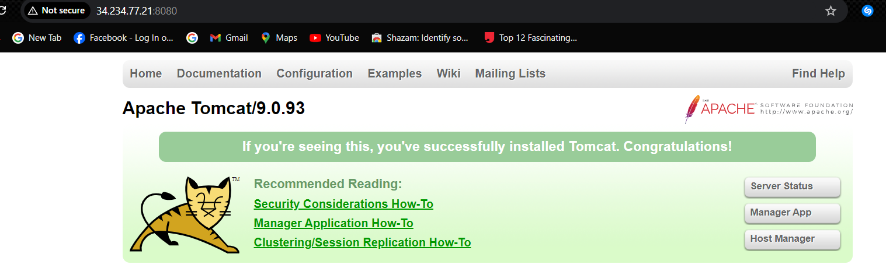

* **Click on manage apps and press the user id and pass word then submit it shows the tomcat deployer server**

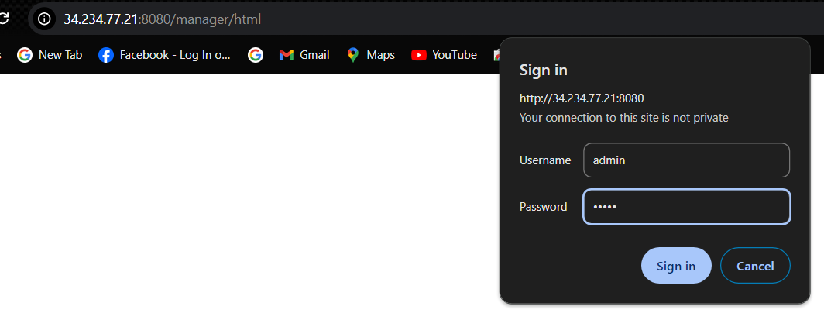

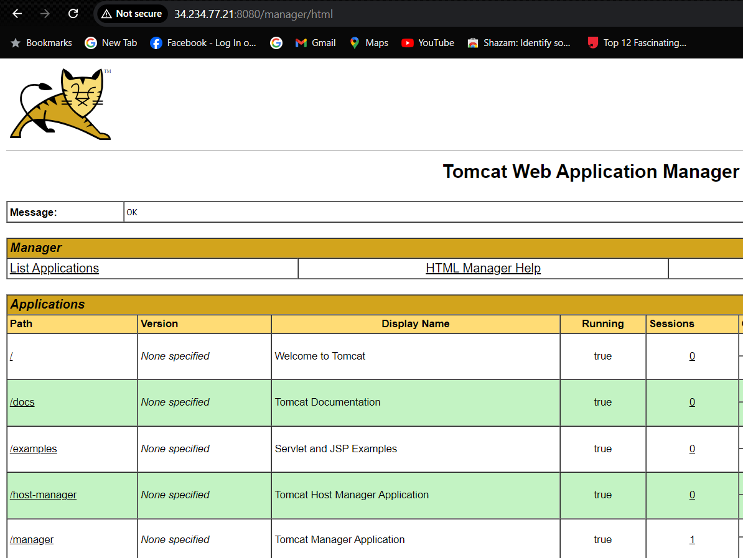

* **Next head back to our Jenkins dashboard**
* **Go to the manage Jenkins 🡪 system 🡪 extended email notifications**
* **Add the SMTP server (smtp.gmail.com) and SMTP Port (465)**

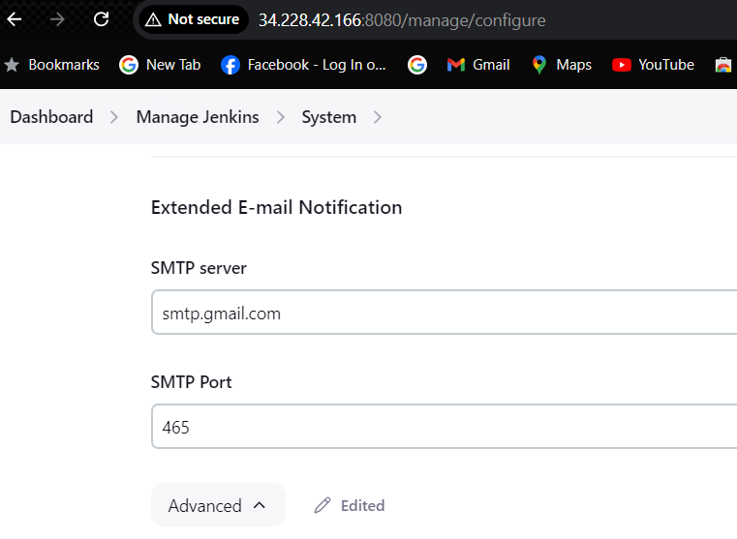

* **Now add the Jenkins credential for Jenkins to access you Gmail**

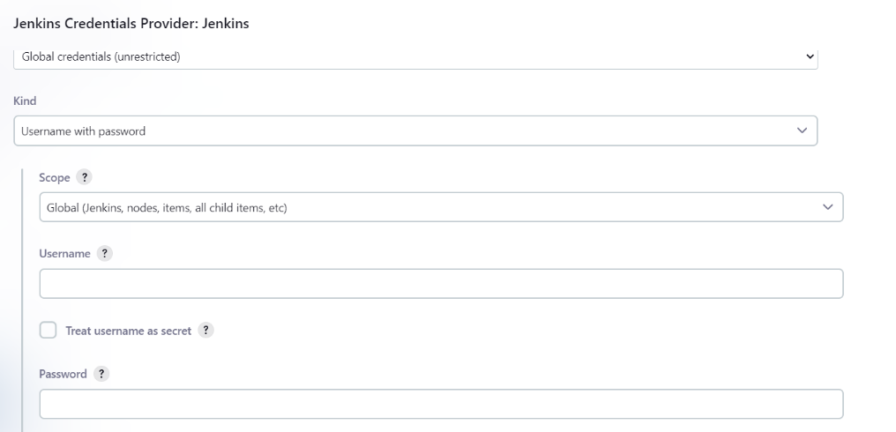

* **In the username give your Gmail id**
* **Next in the password we need to give the app password from your Gmail not our Gmail password**
* **To get the app password go to your Gmail manager your google account 🡪 search for app password**

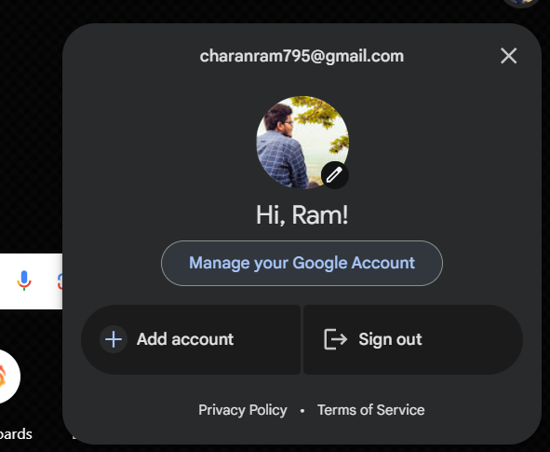

* **Search for app password entre the name as jenkins and click on create**

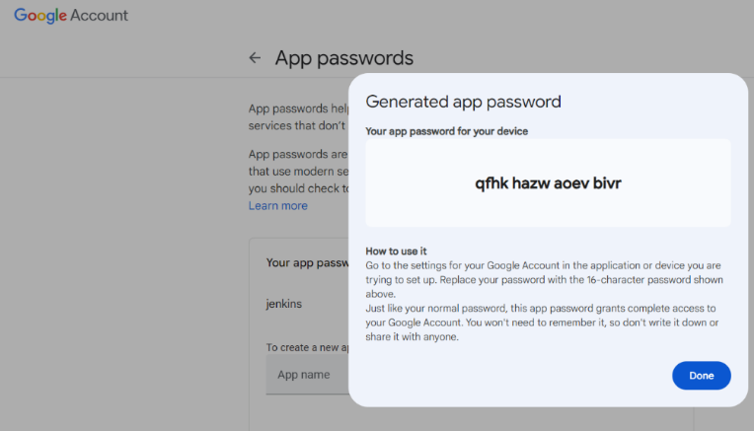

* **Copy the code and past it in the password section with the Gmail**

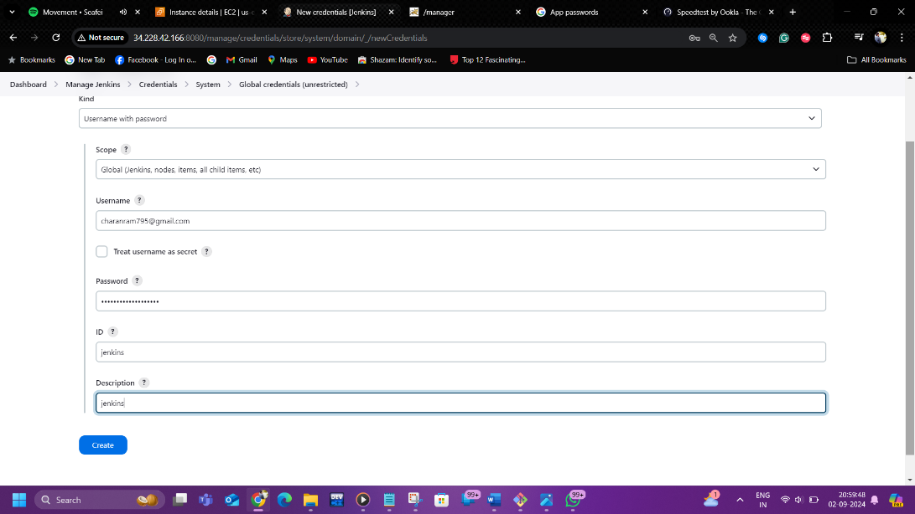

* **Now click on add and enable SSL**

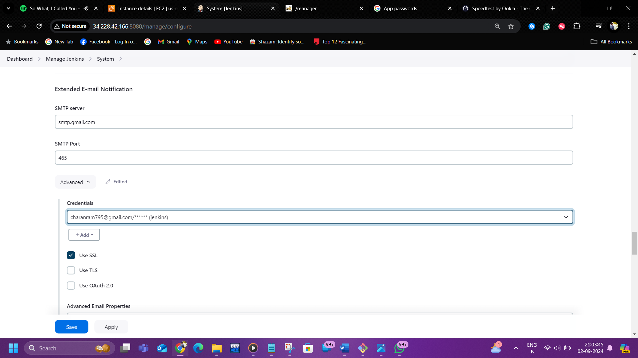

* **Select default context type as 🡪 html for understandable result in the mail**

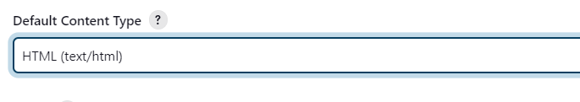

* **Select enable debug mode**

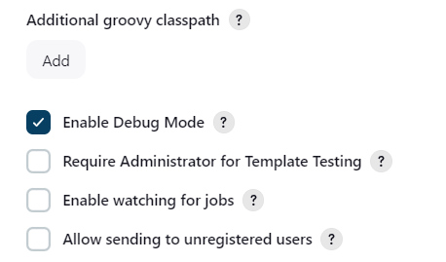

* **In triggers you need to enable 🡪 Always,Failure,success**

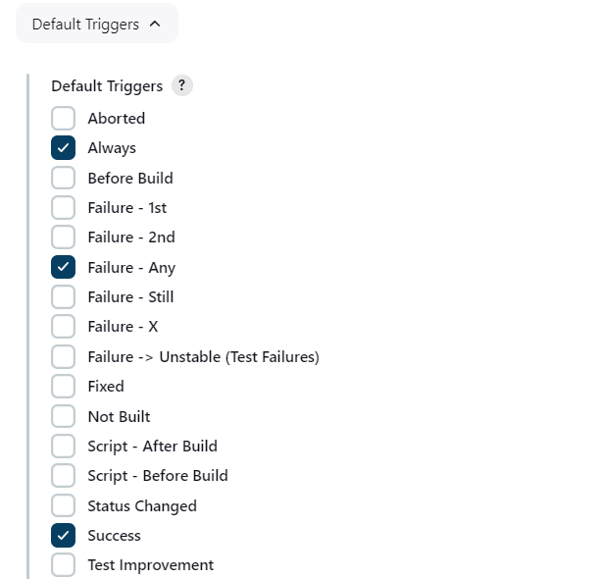

* **In the SMTP server (smtp.gmail.com) & default user e-mail suffix (@gmail.com)**

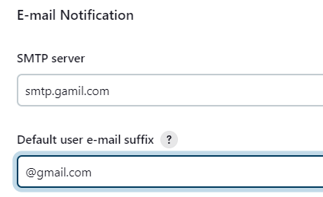

* **In advance enable Use SMTP Authentication (here give the app password from the Jenkins) & Use SSL**

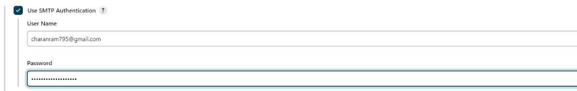

* **SMTP Port (465)**
* **Now enable test configuration by sending test e-mail entre your email (**[**charanram795@gmail.com**](mailto:charanram795@gmail.com)**) to send a test mail if its sent it appears successfully sent & click on apply and save**

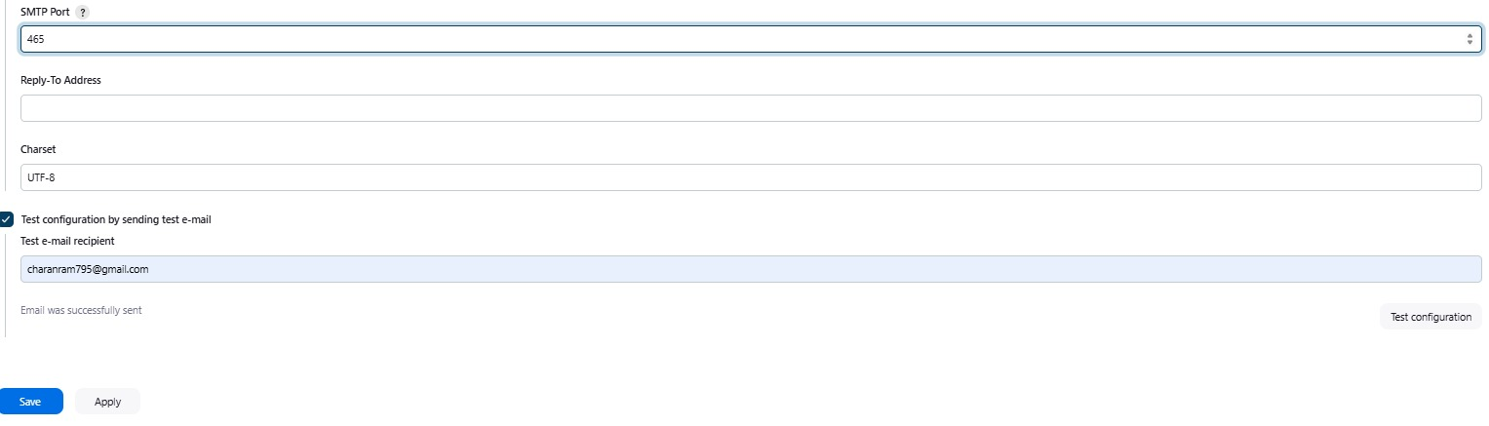

* **Here is the email that I received**

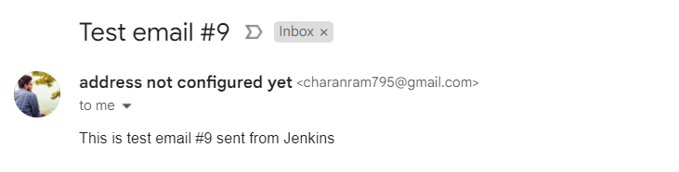

* Next go the dashboard and create the job with the pipeline and click on ok

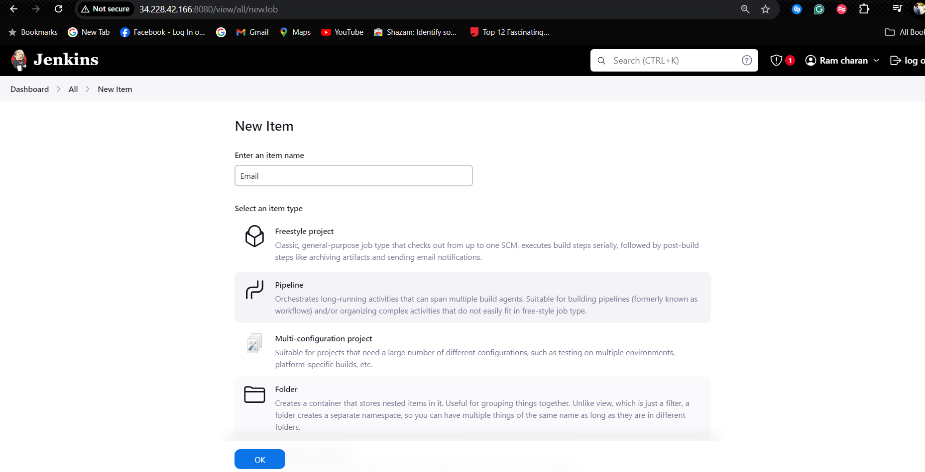

* Now move to the pipeline selection and start writing the basic command to clone a repository click on generate the pipeline syntax

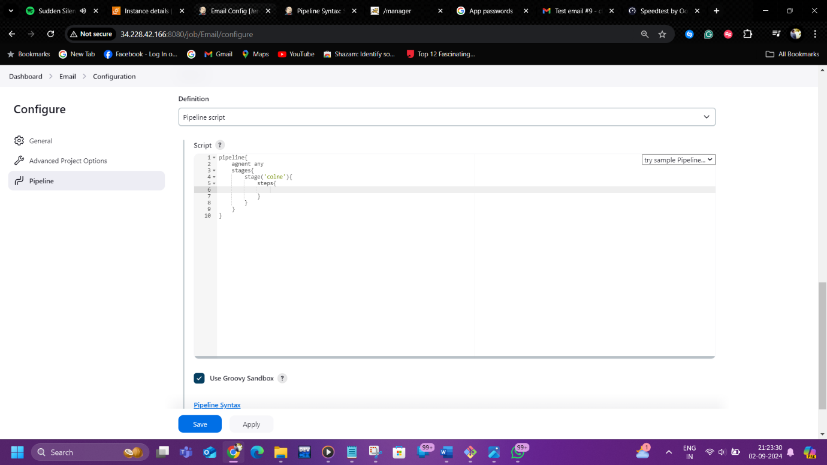

* Now click on pipeline syntax and select checkout :check out from version contro

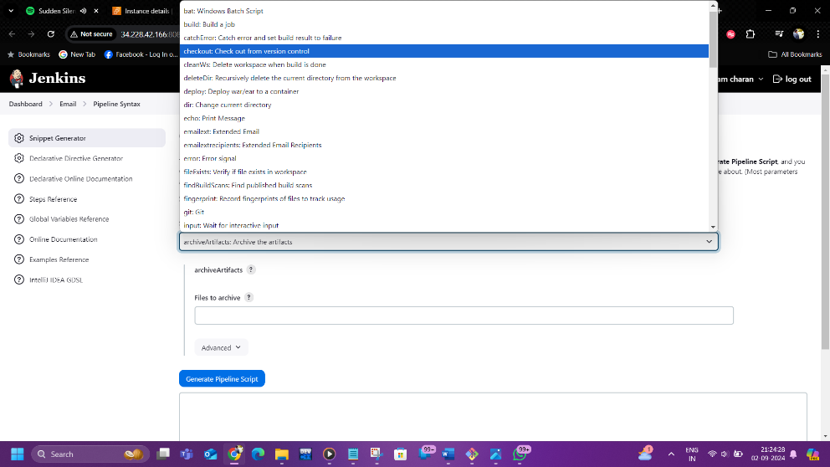

* Next get you git-hub URL and past in the Git-hub URL

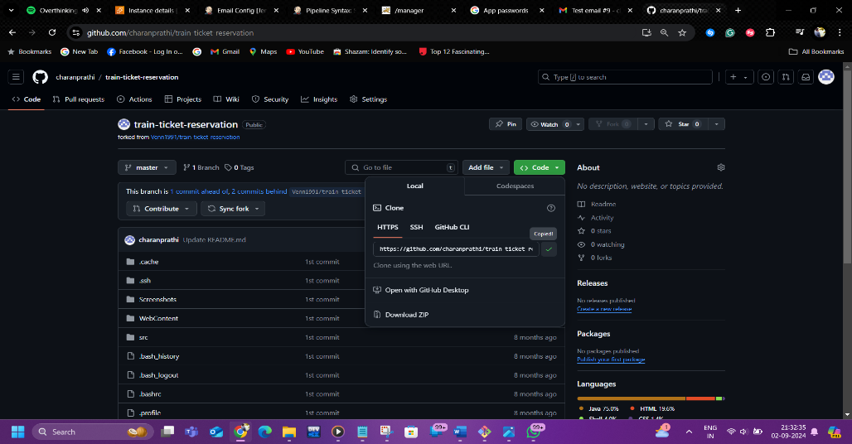

* if our repository is private need to give the credentials. I have a public repository

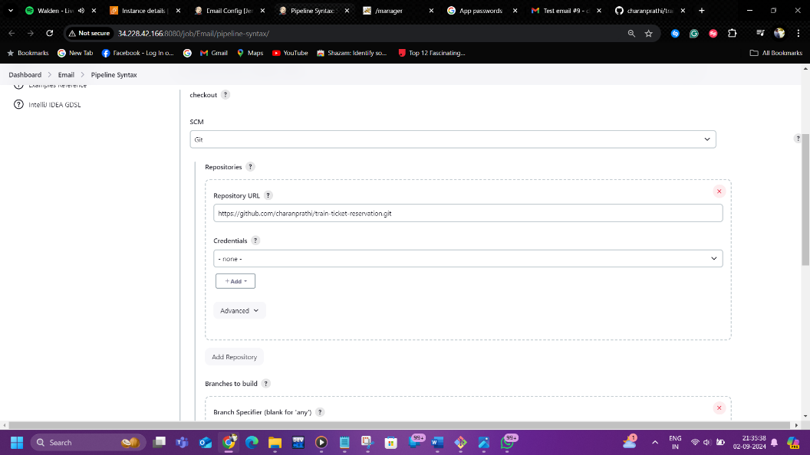

* Click on generate pipeline script

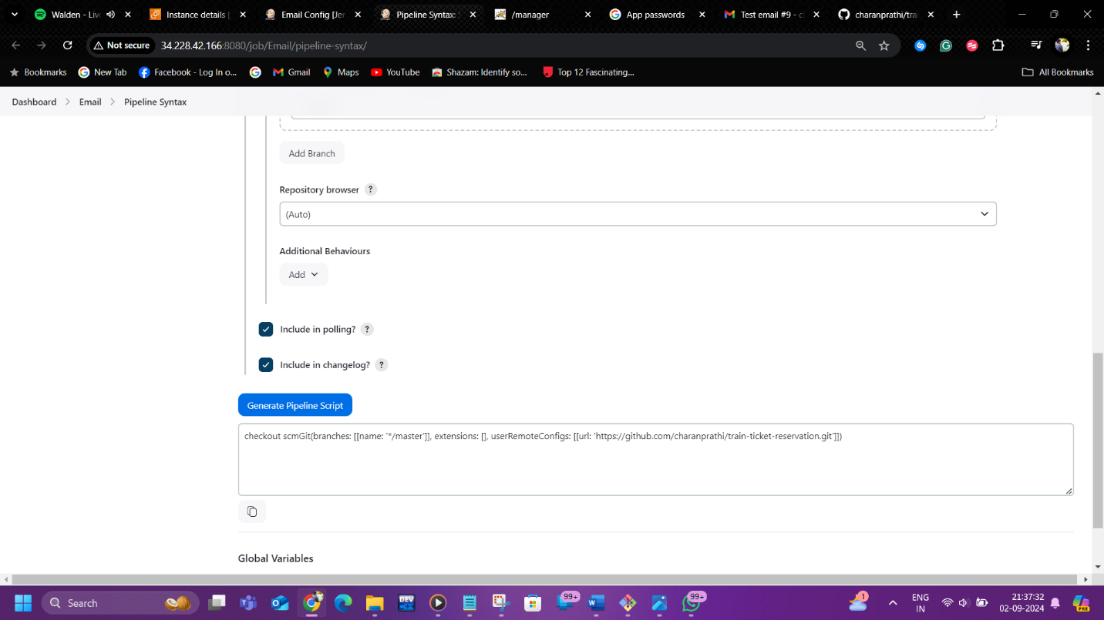

* Copy the syntax and past it in the clone stage

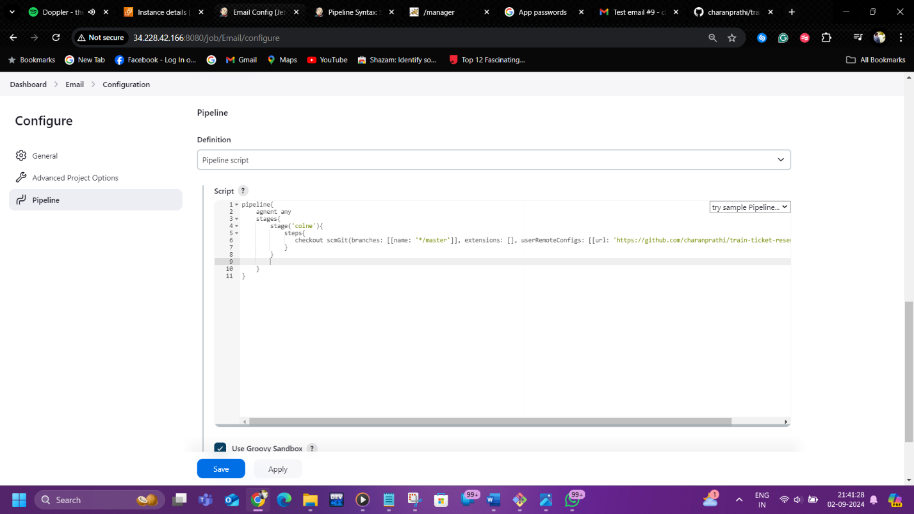

* Now write the code to validate, compile, test, package in the stage thought the shell script as shown below

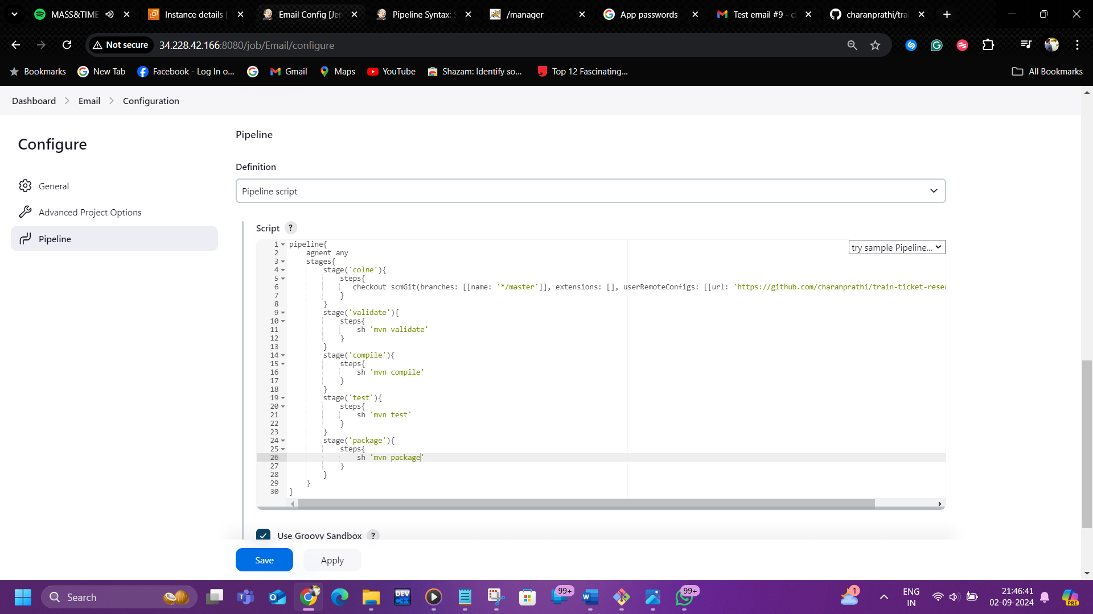

* we should generate the pipeline syntax for the deployment of java application in tomcat server.
* Select deploy – deploy war/ear in the context file

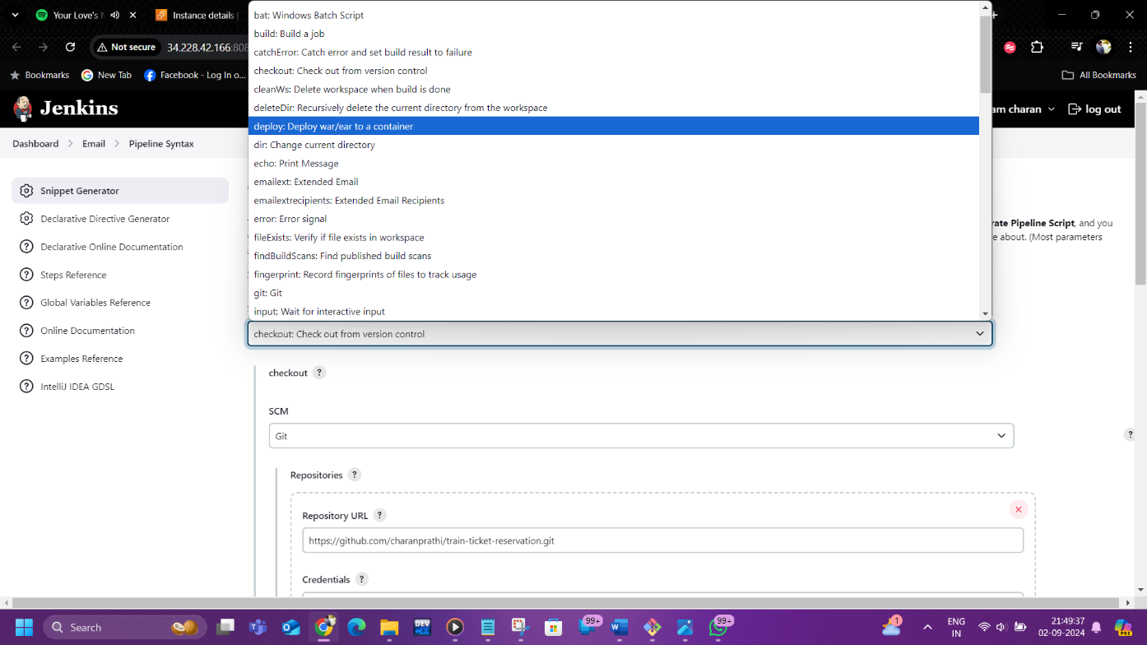

* Now give the war file (**/*.war) and the context file (train)

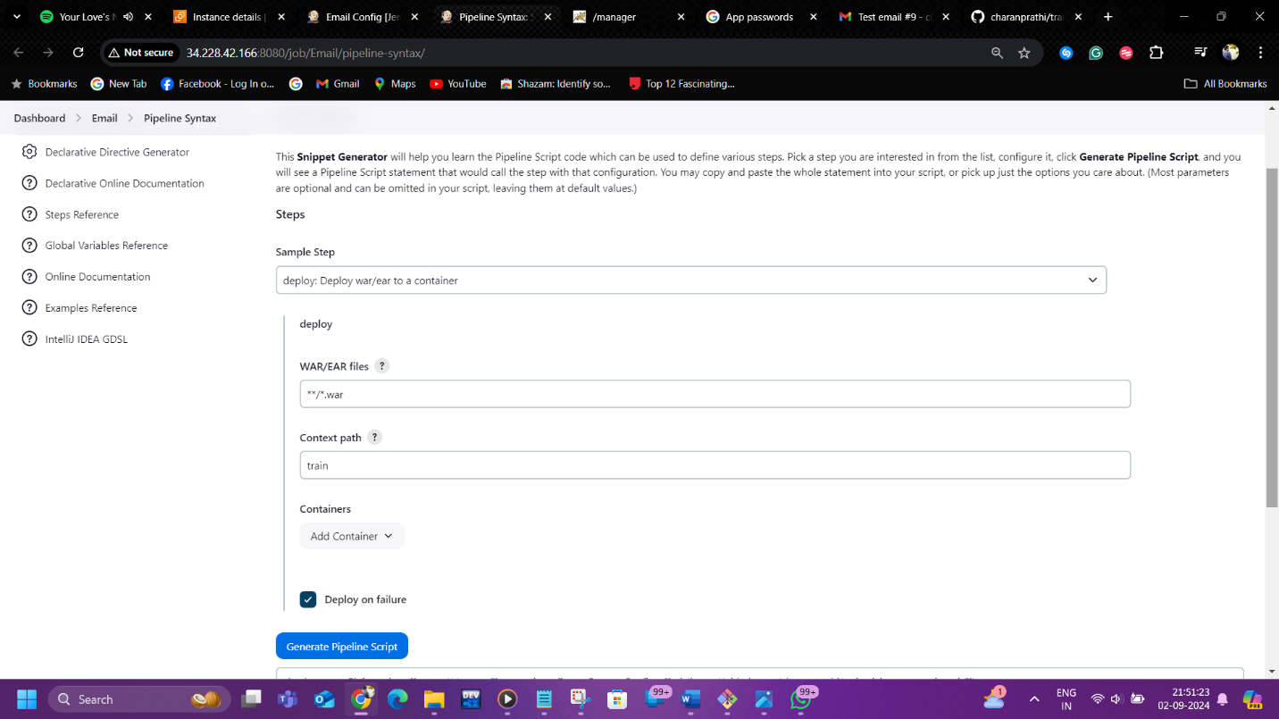

* Now click on add container 🡪 tomcat_9-Remote

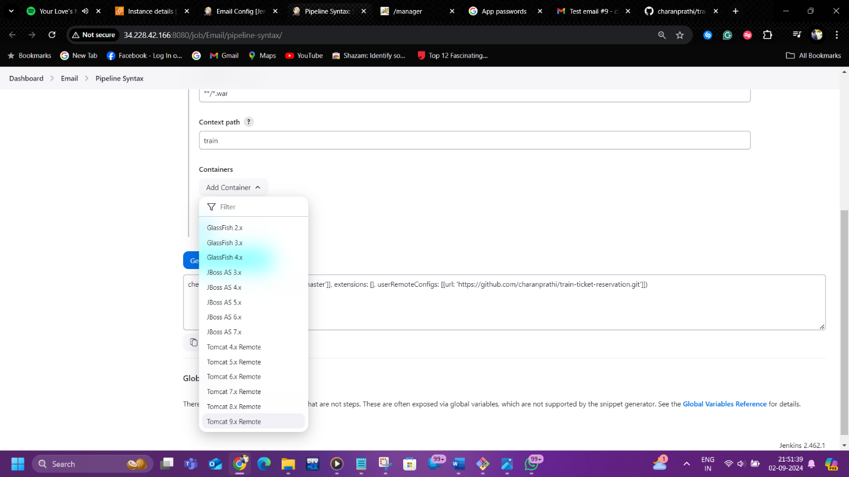

* We need to give the credentials for tomcat in the Jenkins

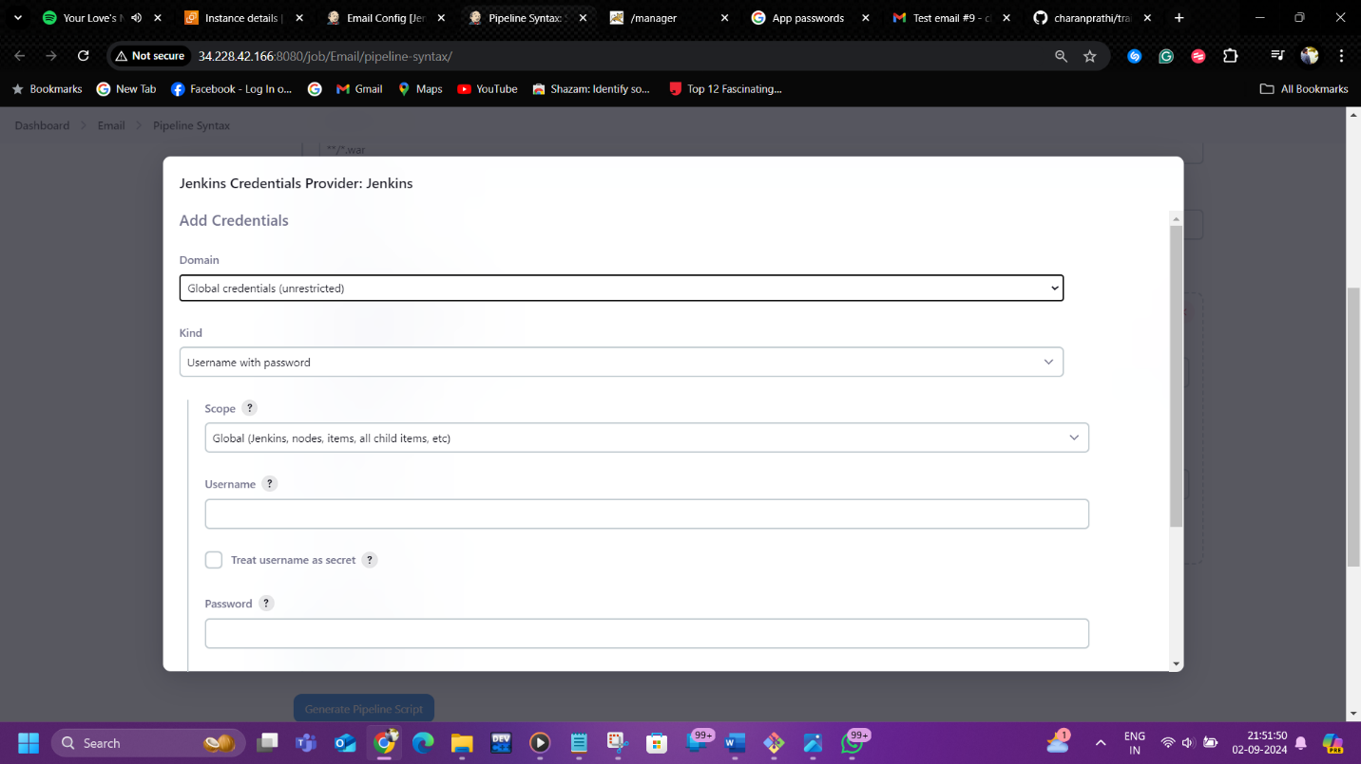

* Add the username (deployer) password(deployer) and give the description and id as (tomcat & t1)

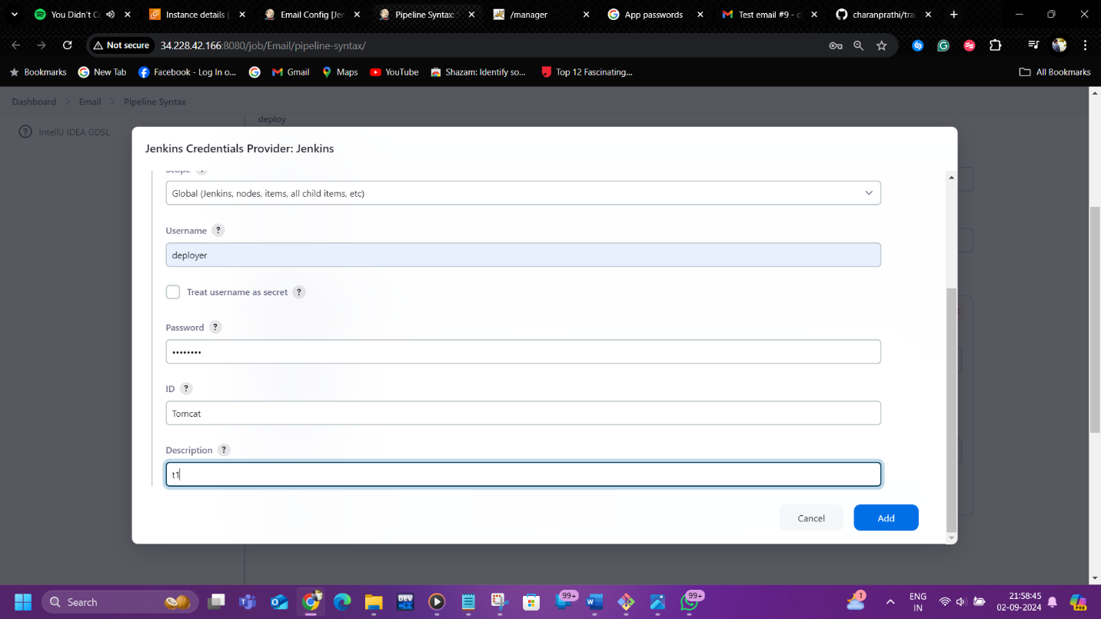

* Next give your tomcat server URL and click on generate the pipeline syntax

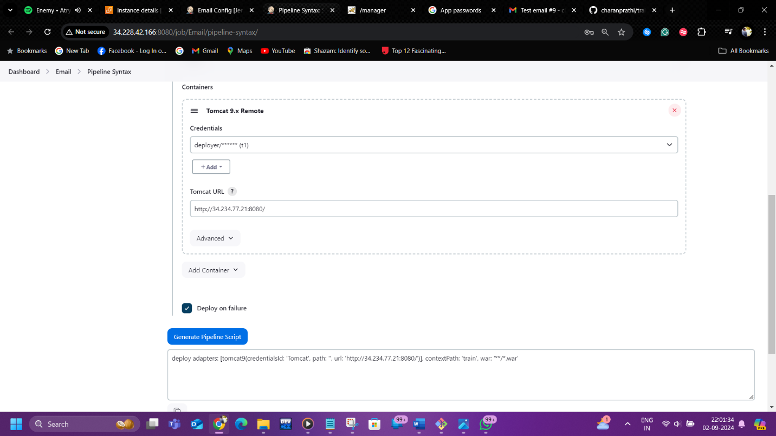

* Copy the pipeline syntax to the pipeline script area and past in the stage area as shown below

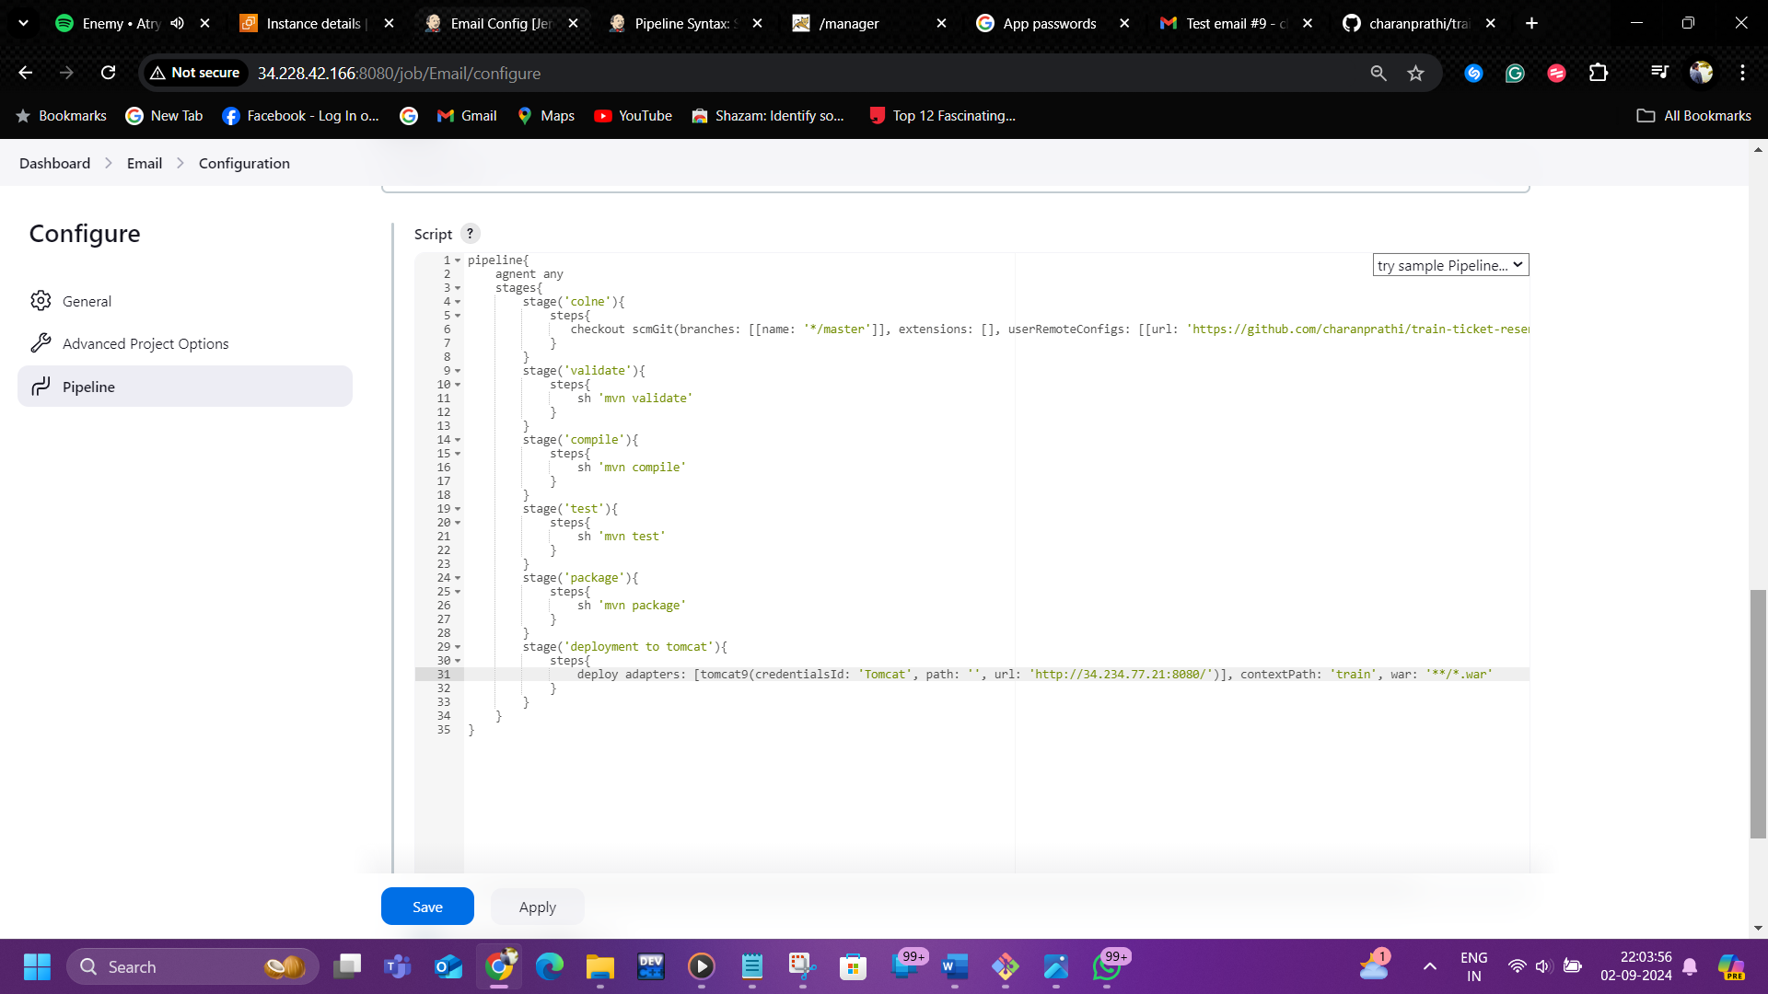

* Next need pipeline script from Email now go pipeline syntax and select Email extend email

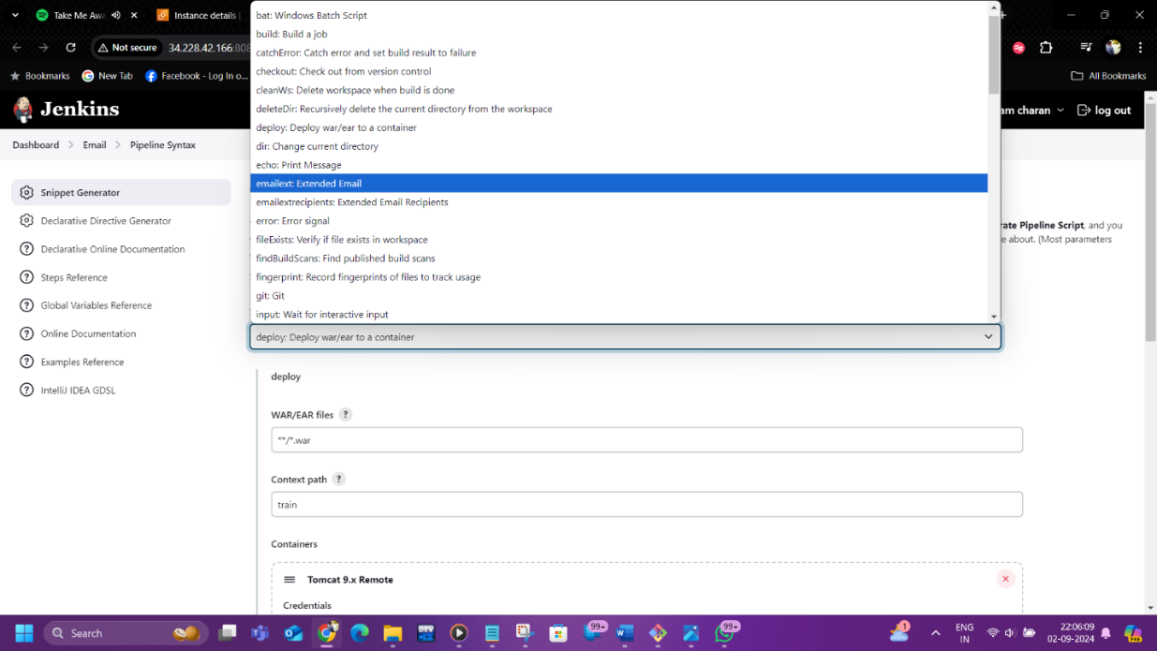

* After selecting email extended Email, we need to give the Email([charanram795@gmail.com](mailto:charanram795@gmail.com)) in TO
* And add the subject and body to the sections

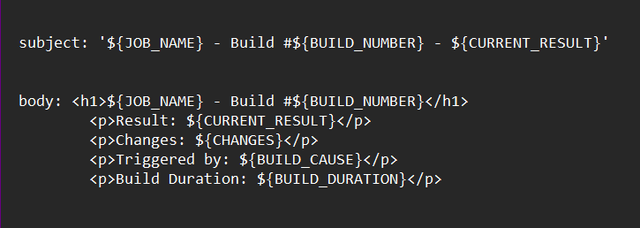

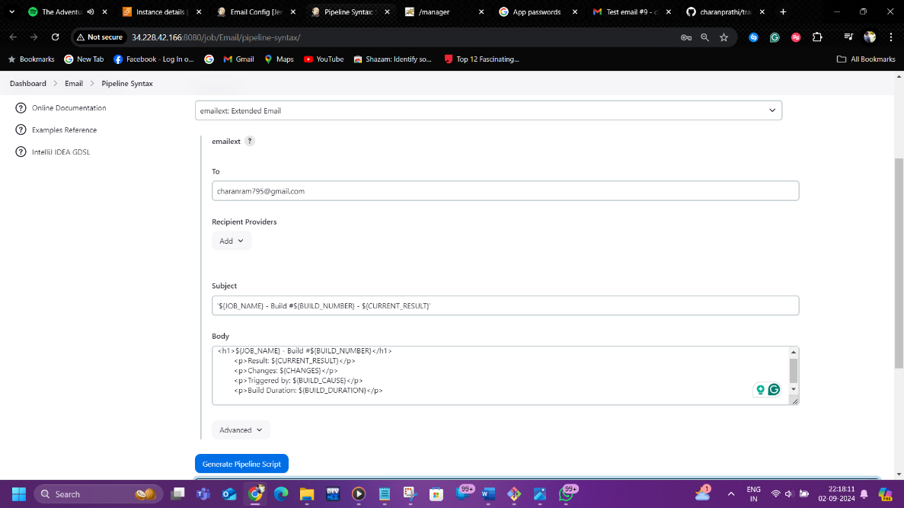

* Now click on generate pipeline syntax and past it in the pipeline script

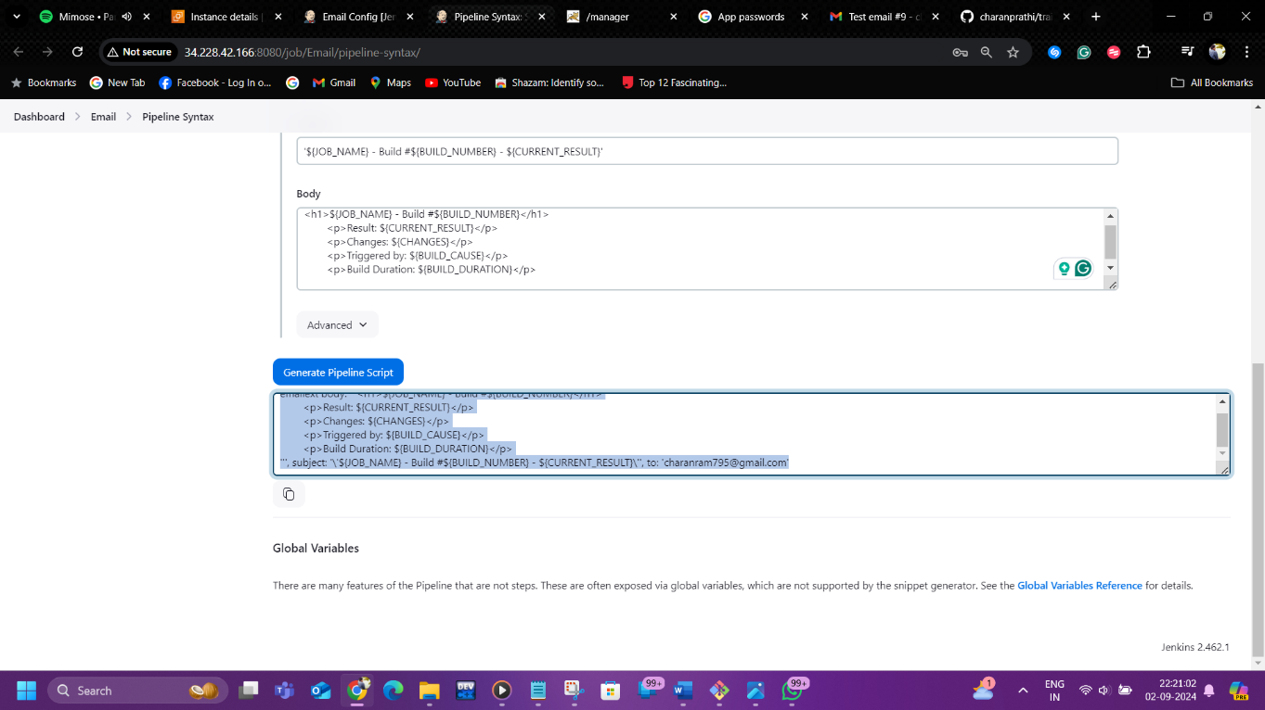

* Past the code as show below with the post & always command in the pipeline script

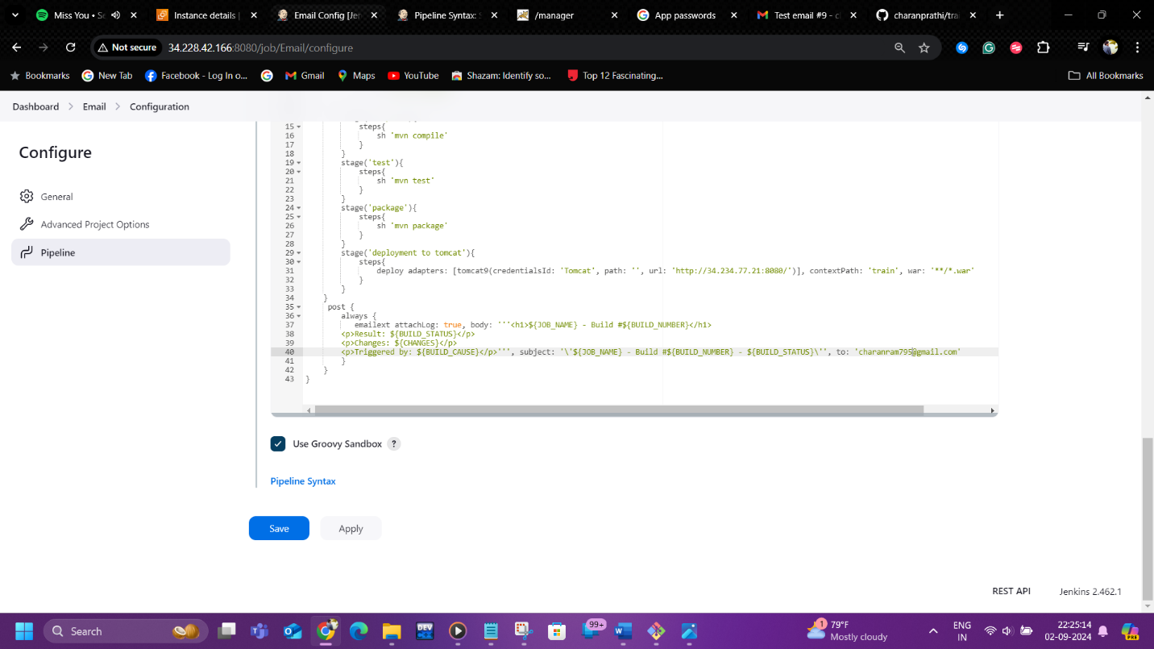

* Click on save and apply

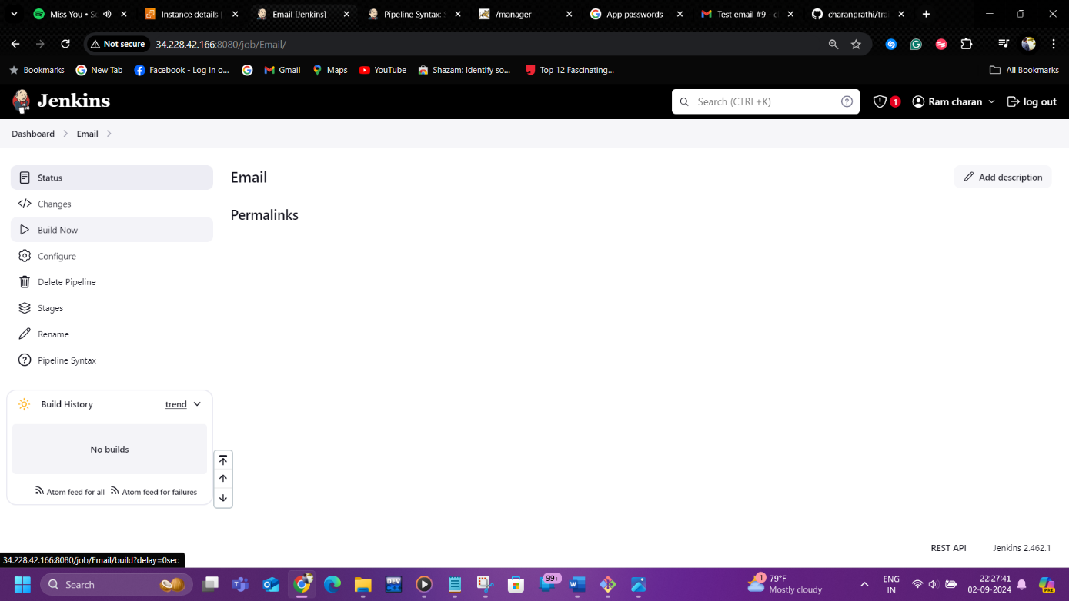

* Next click on build now and open stages & Now its successfully deployed and posted email

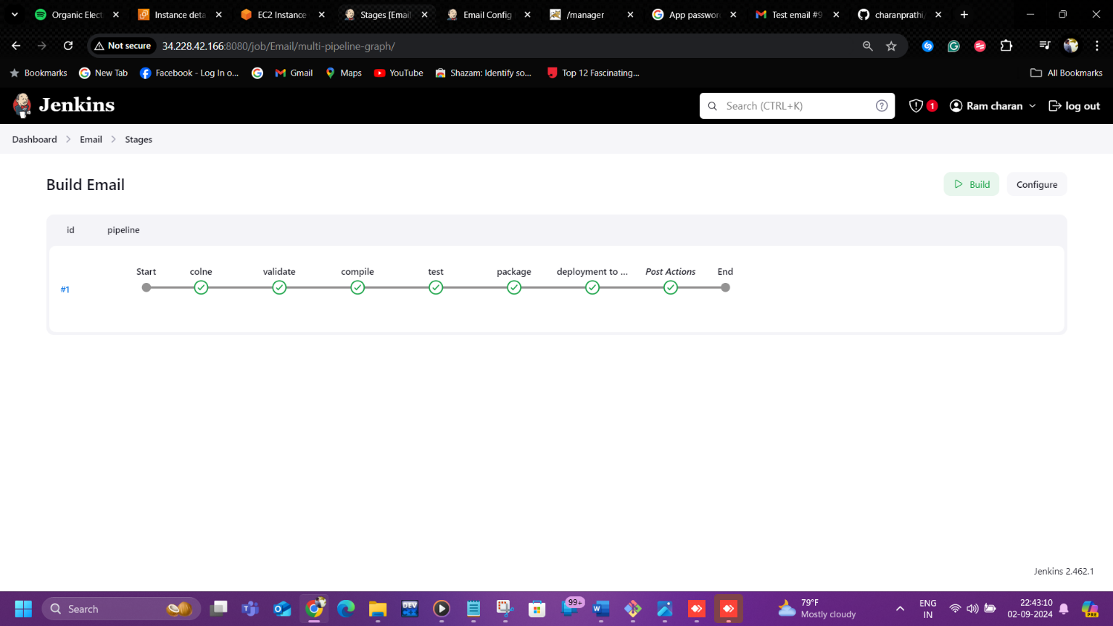

* Let’s check eighter the application is deployed in the tomcat

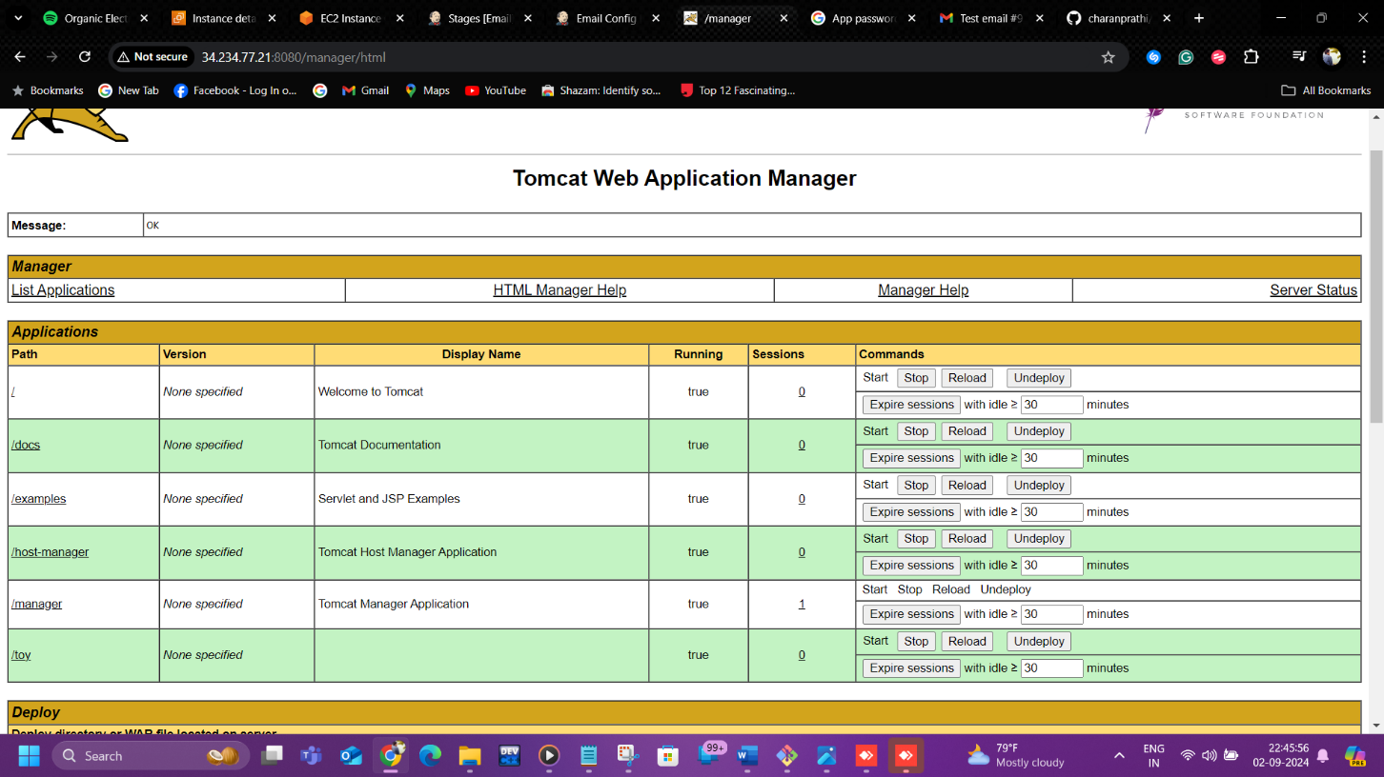

* Now click on toy to see the train-ticket application

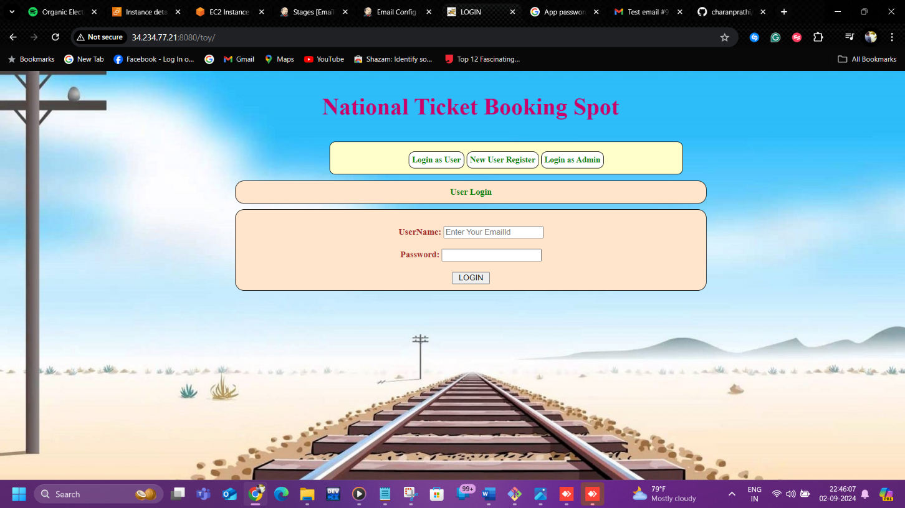

* It shows that mail is posted let’s go and check it

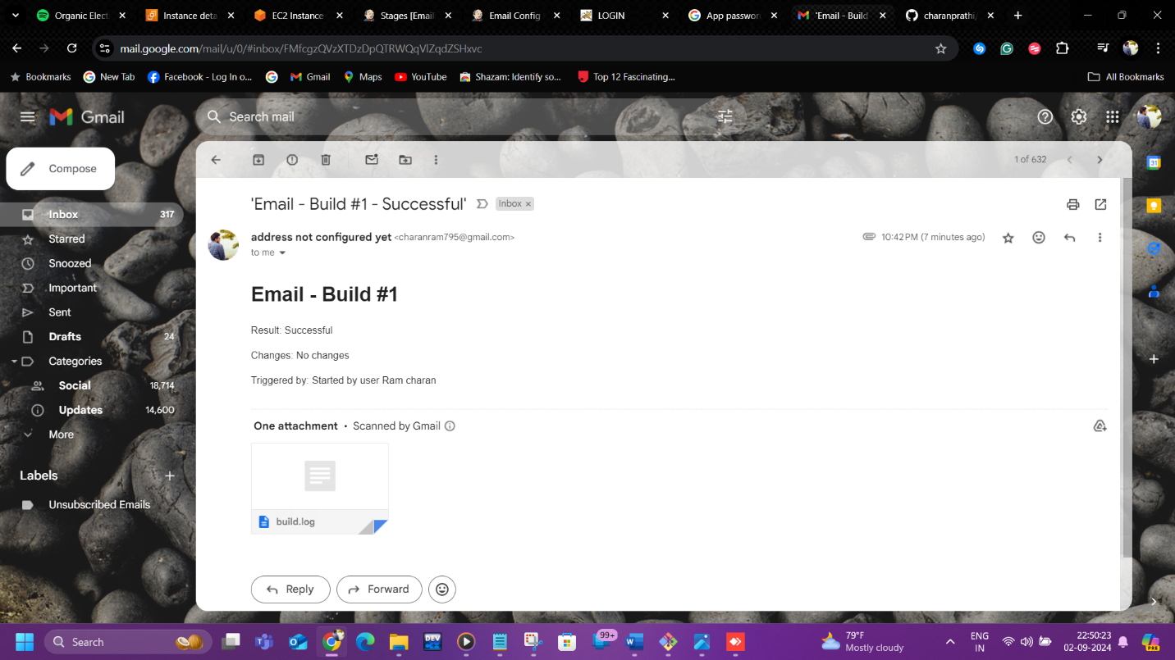

* It comes with an attachment of build log (console output in the Jenkins)

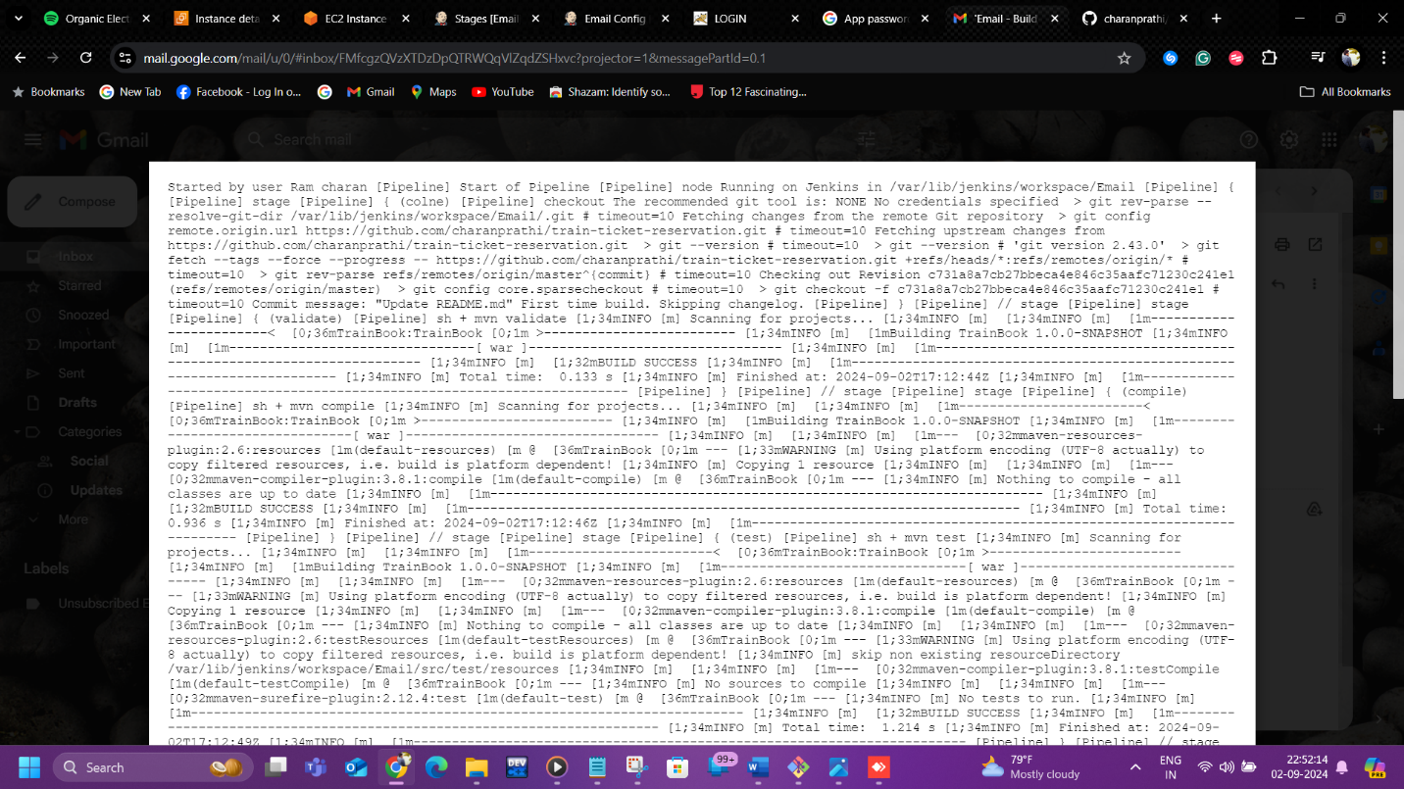

*Thank you*